**Create a virtual machine (VM) in AWS, configure it within a resource group and ensure basic security measures are implemented**

**Login to AWS console and open EC2 services**

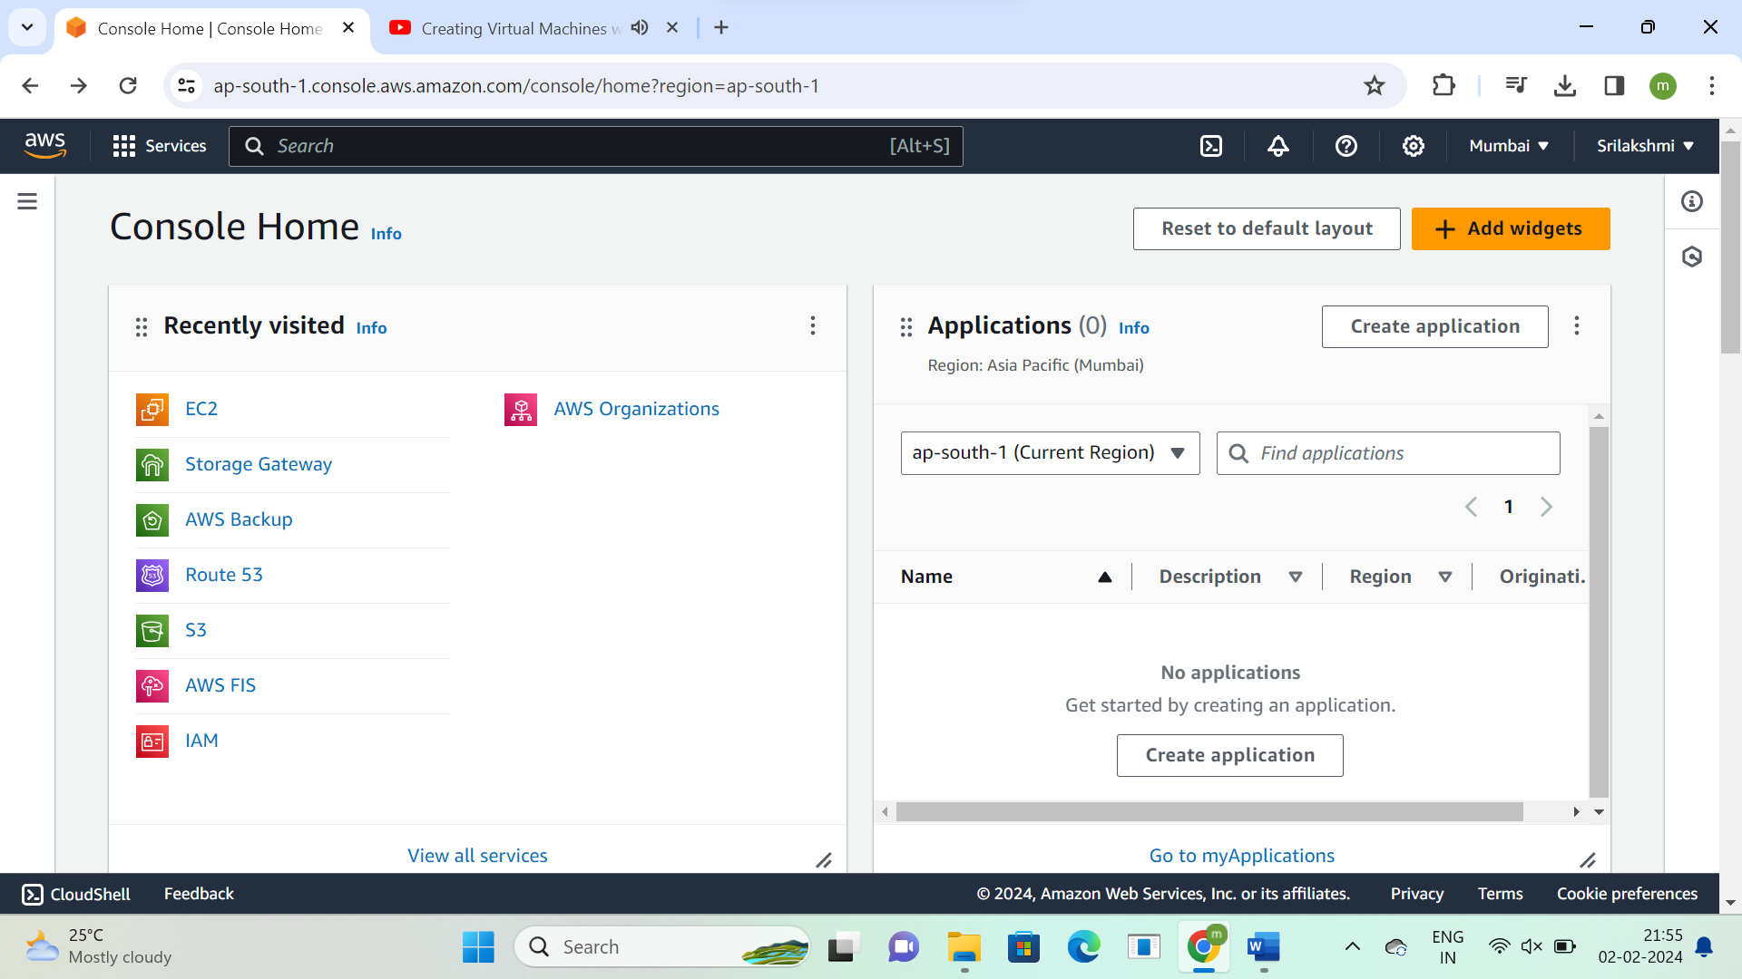

**Go to instances and click on launch instance**

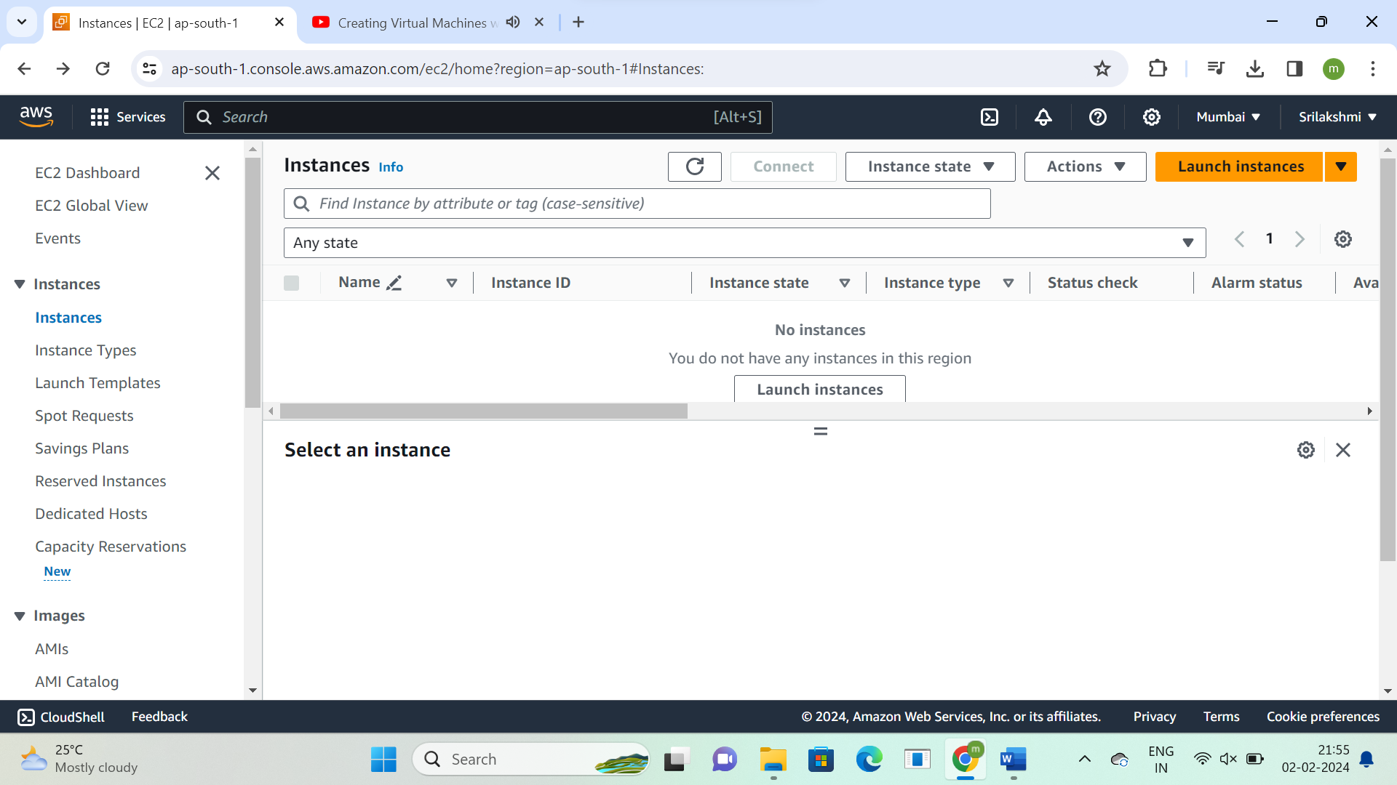

**Instance name – Sritask1**

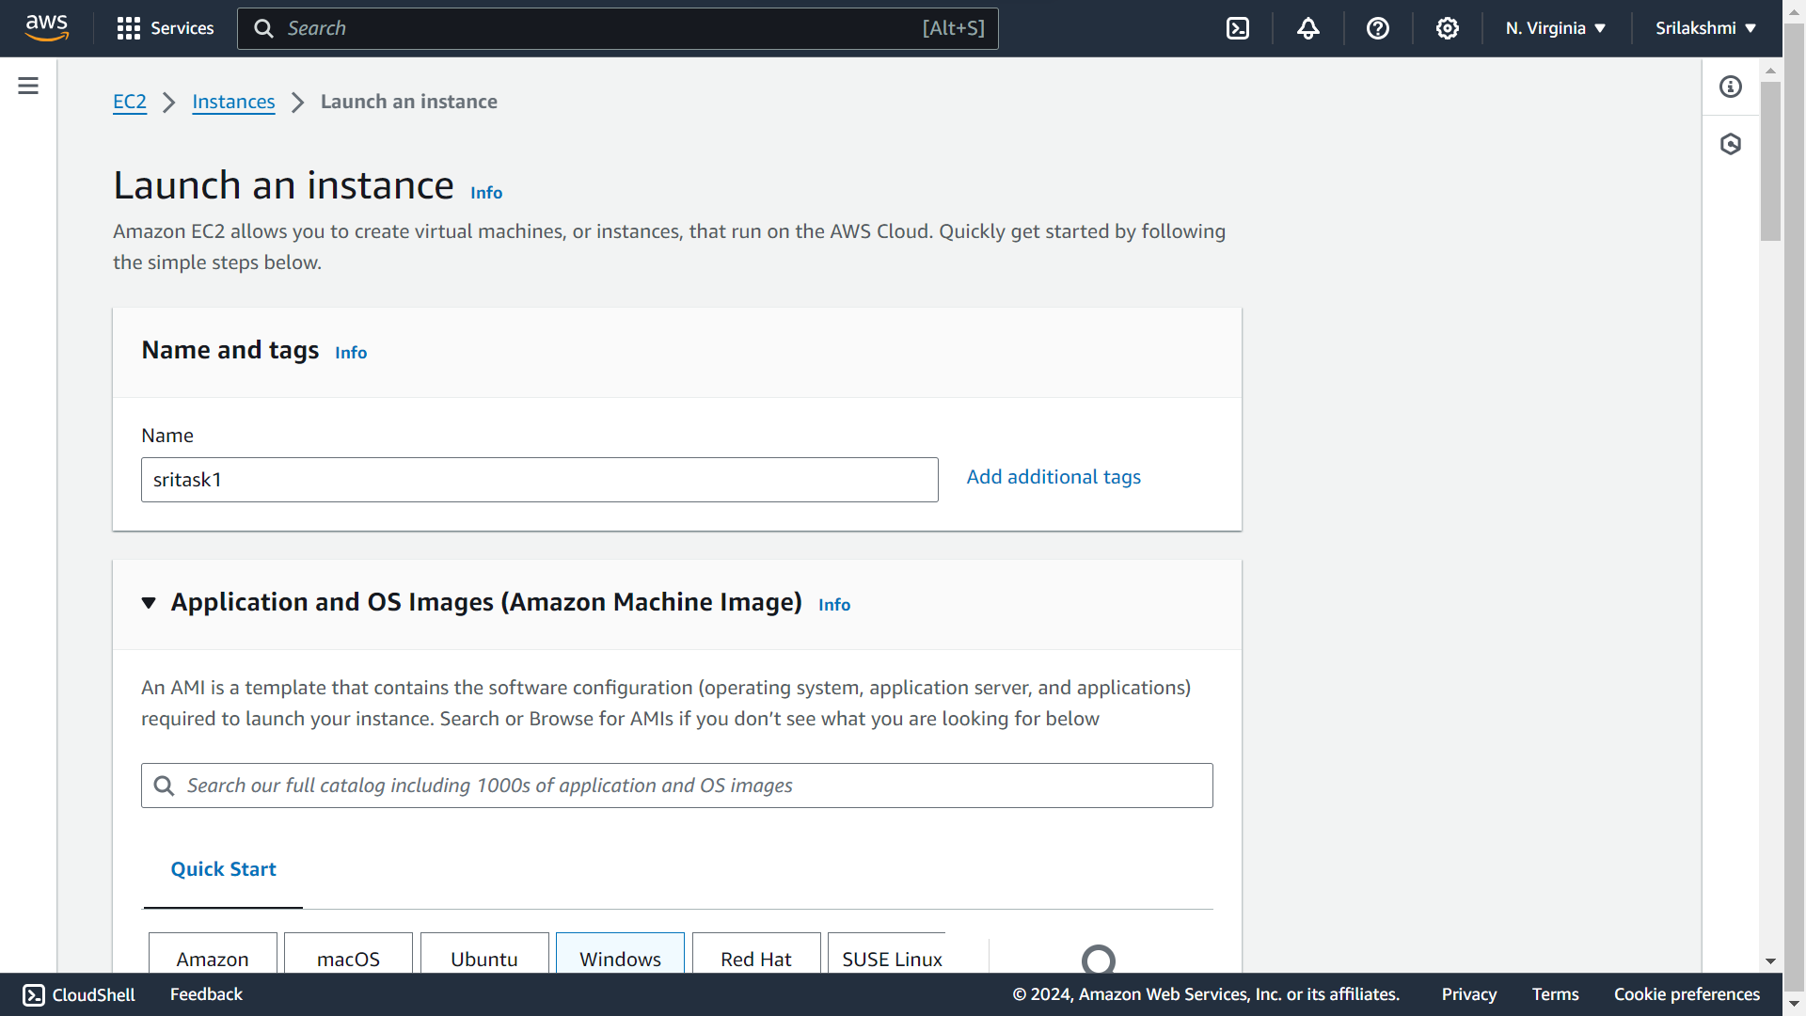

**Select Microsoft windows server 2022 Base**

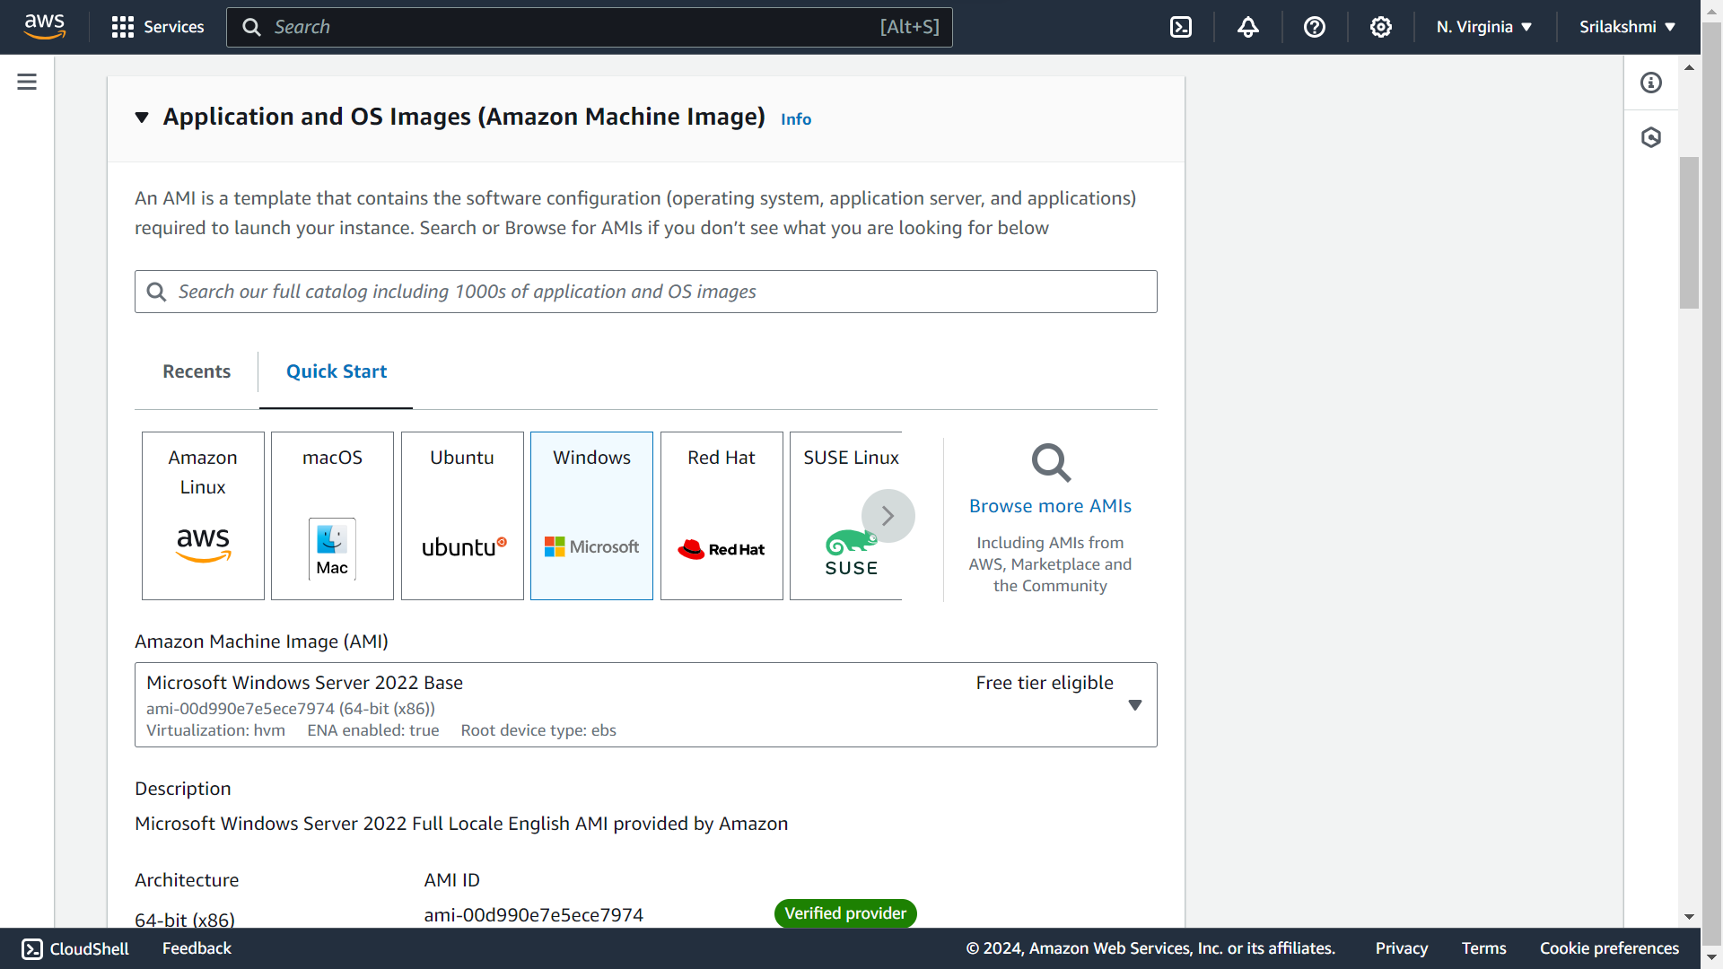

**Instance type-t2.micro**

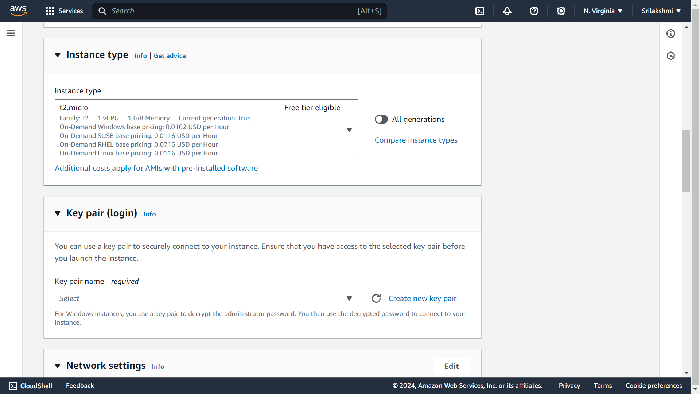

**Create key pair-sritaskkey**

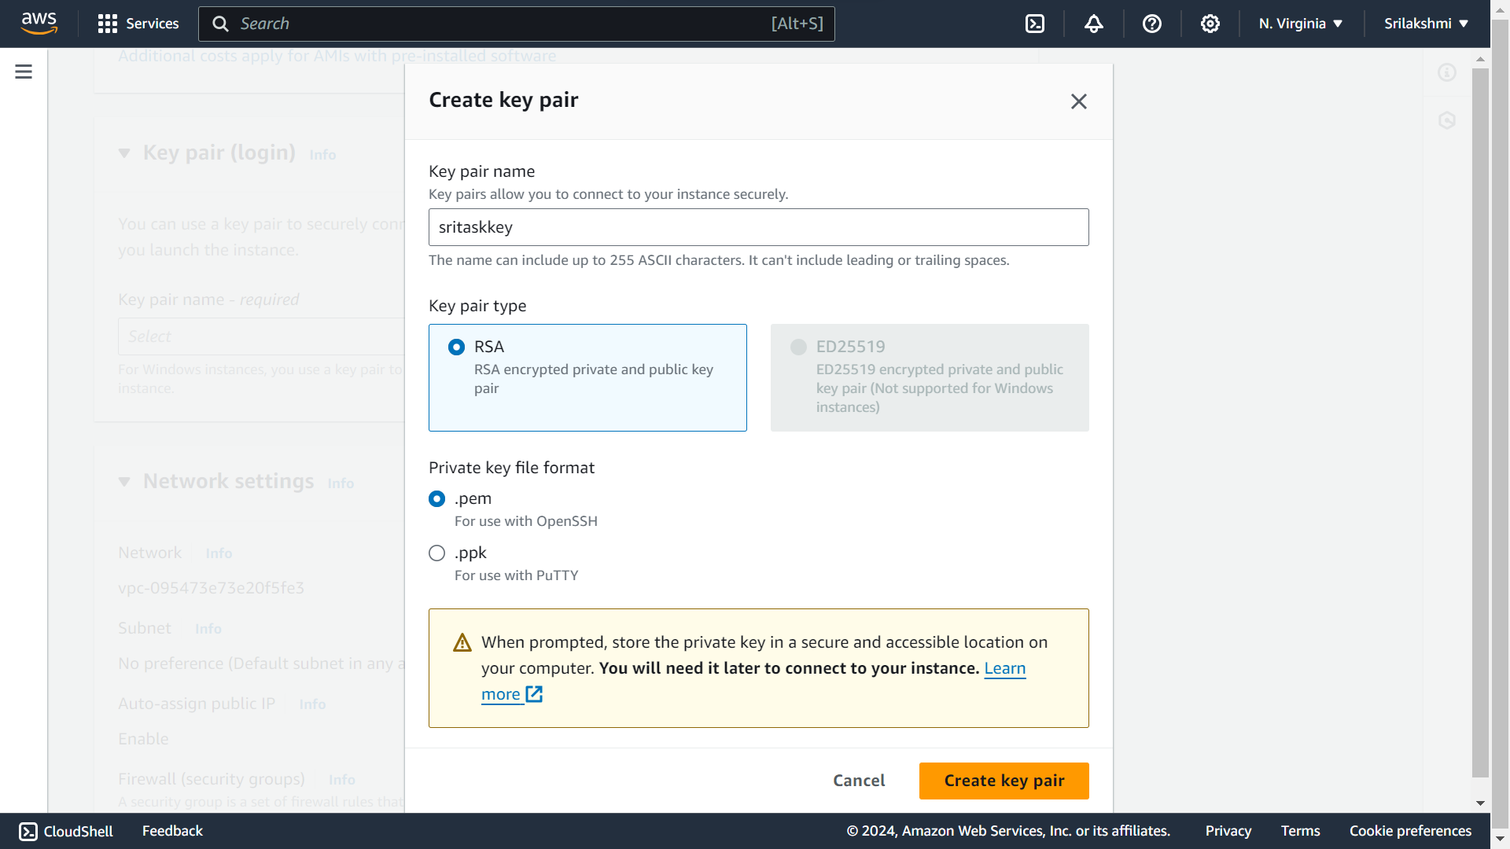

**Network settings**

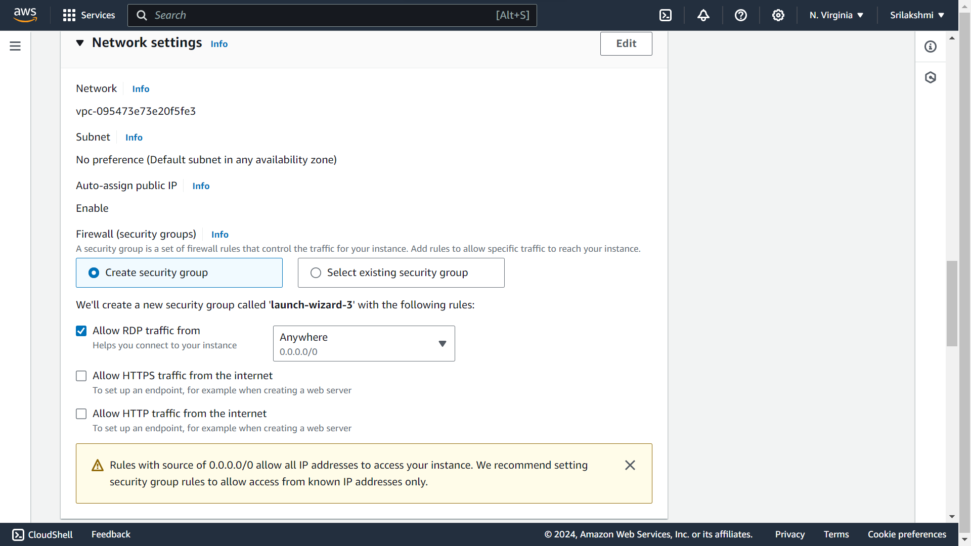

**Configure storage-Gp2 30GB and click on launch instance**

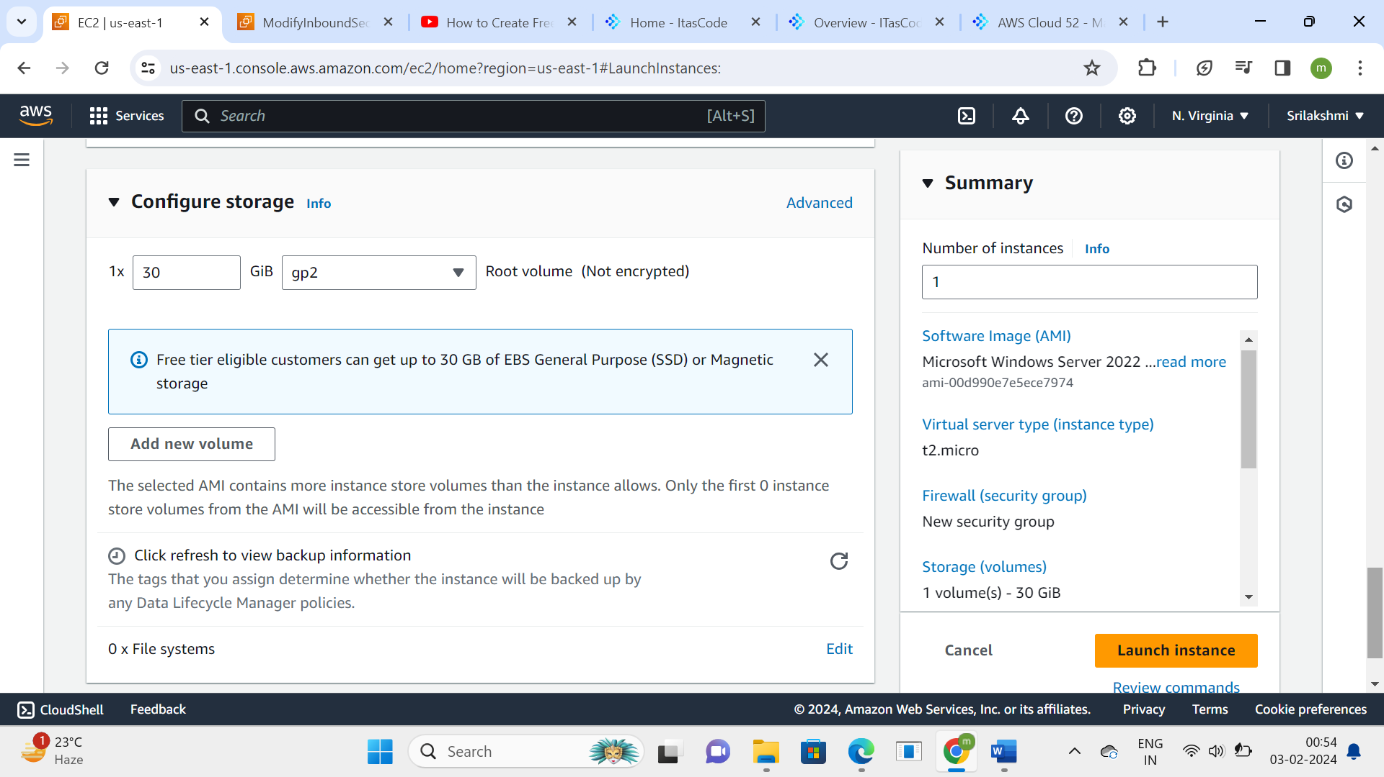

**Go to Instance ID**

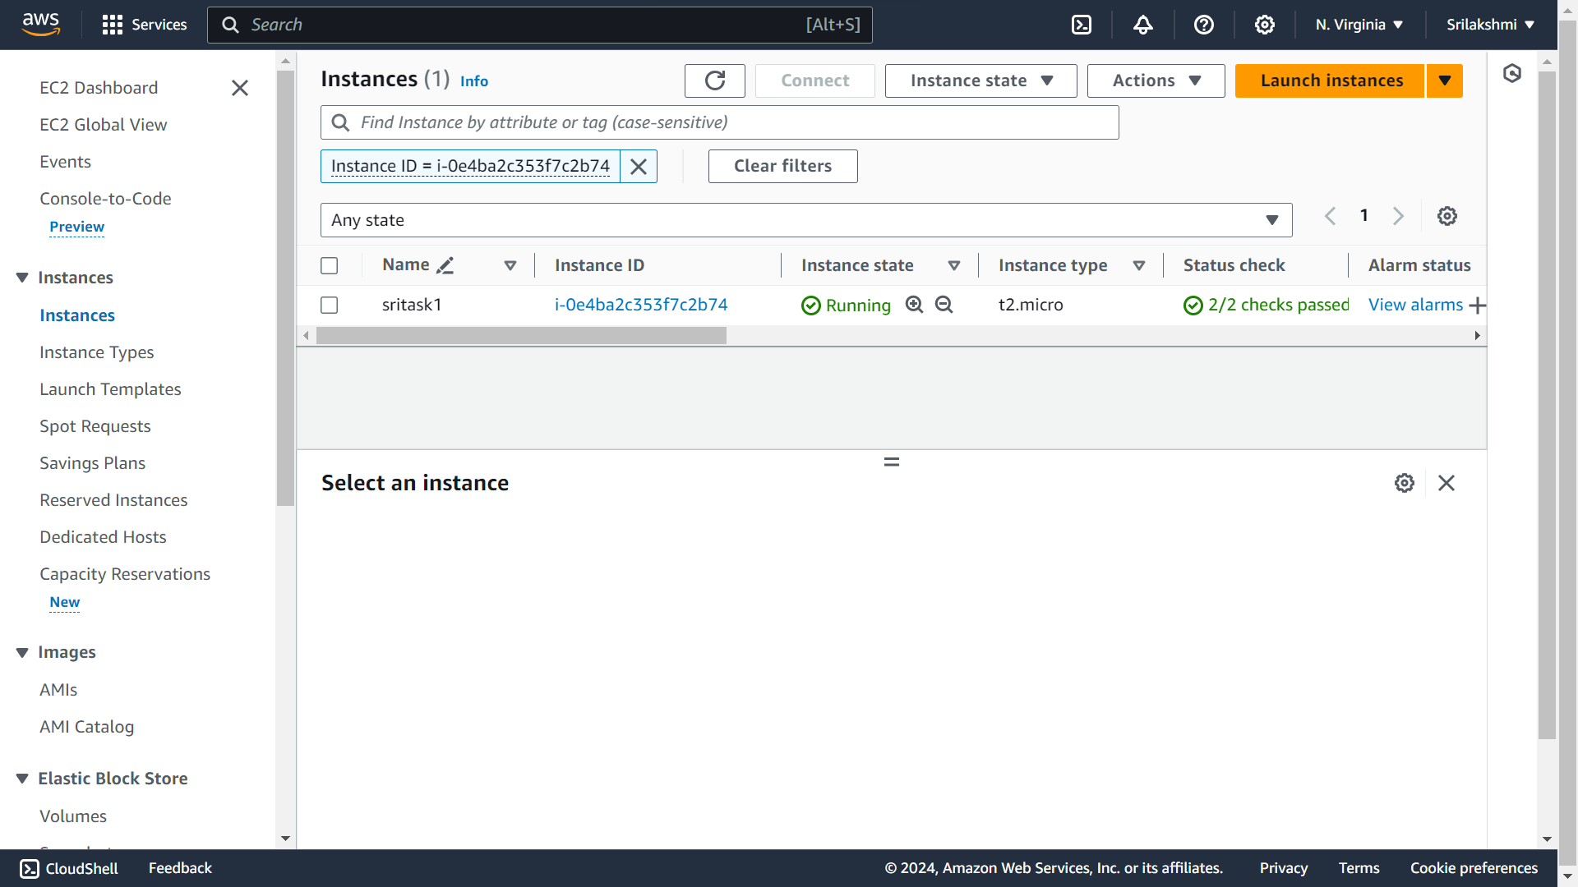

**This is the Instance overview**

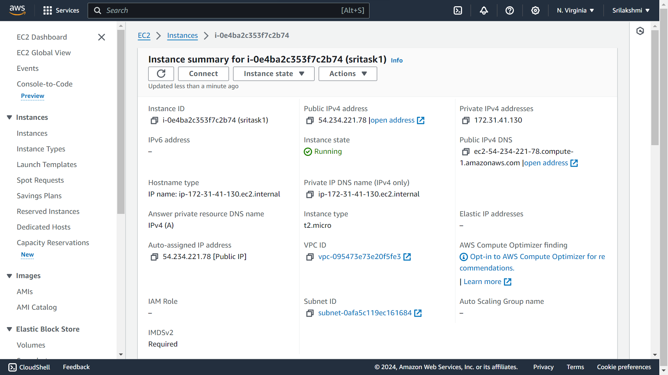

**Go to security option and click on security groups**

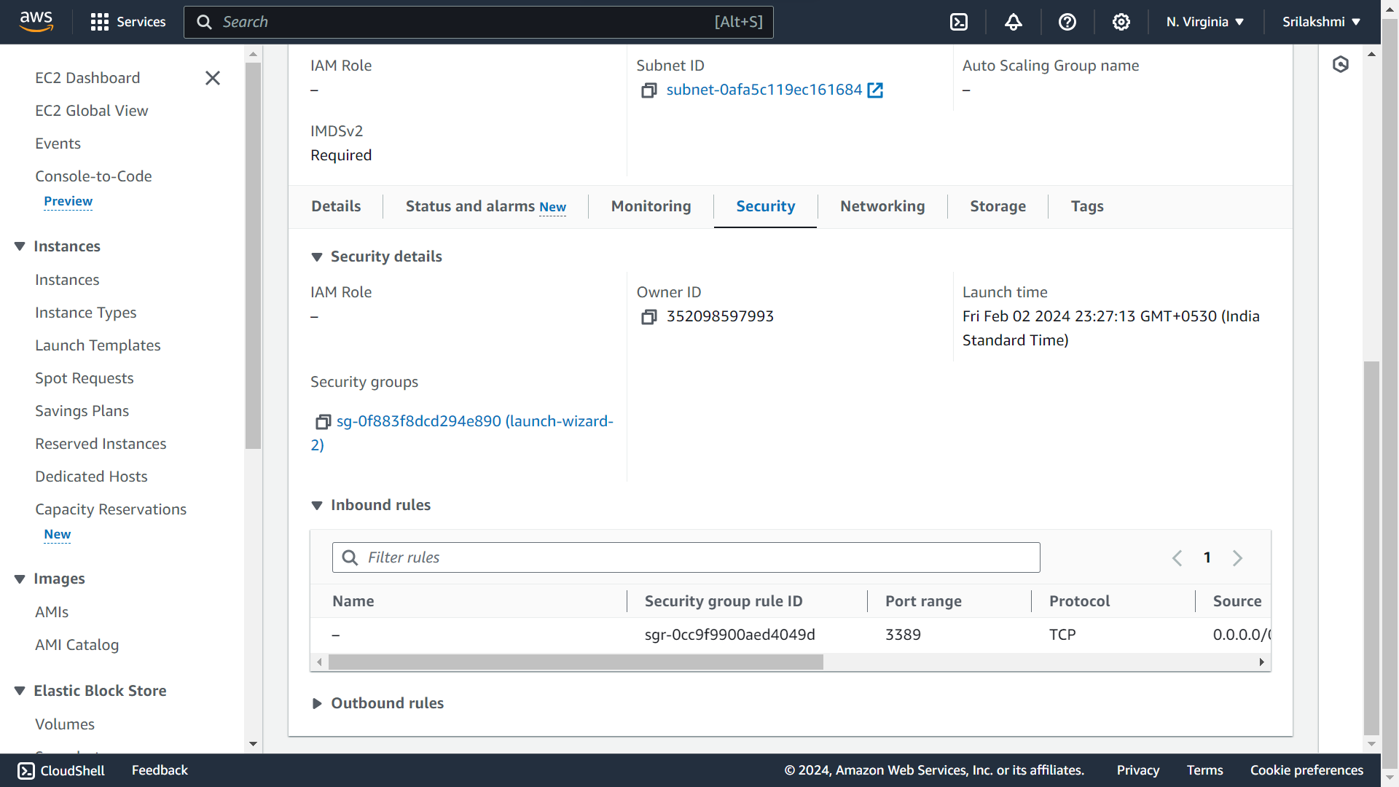

**Click on edit inbound rules**

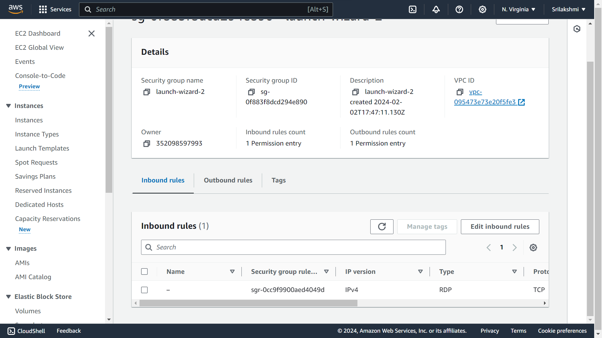

**If we want, we can add the rules and save rules**

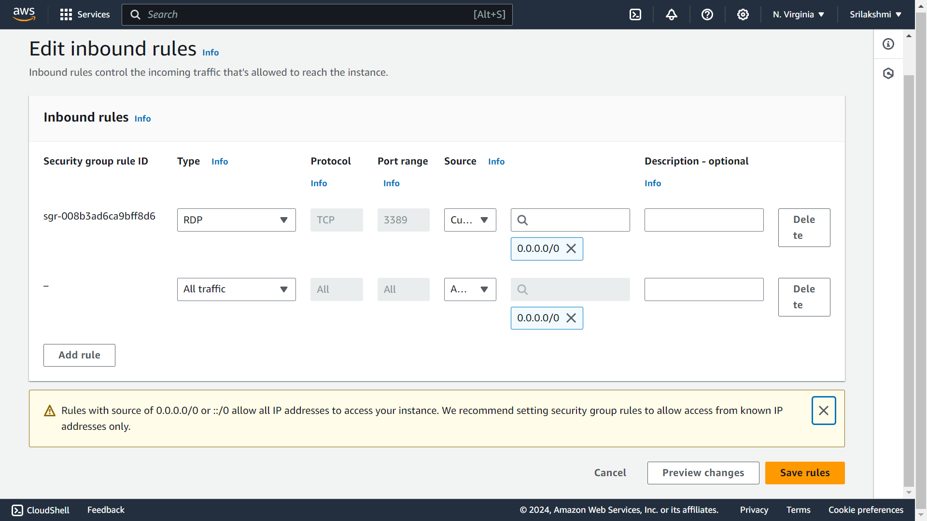

**We can also edit Outbound rules and save rules**

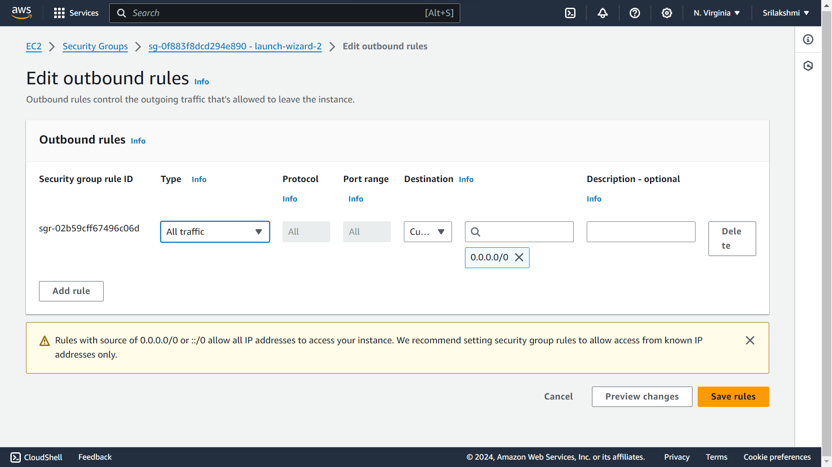

**Click on Create resource group**

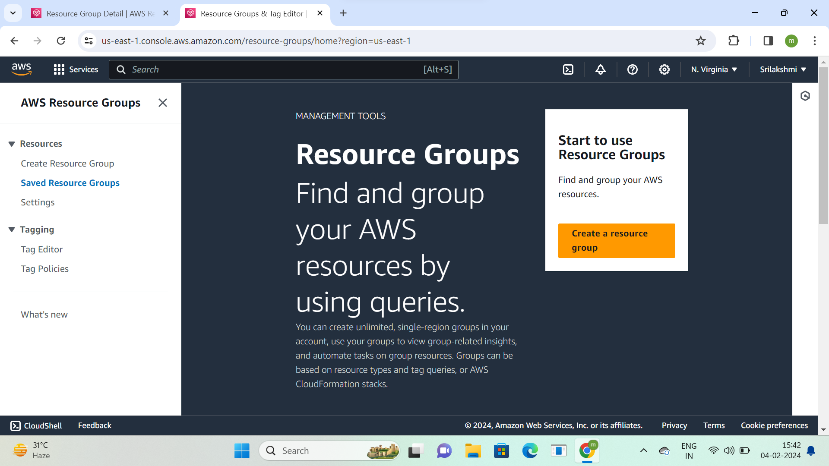

**Go to tag based group type and select resource type-AWS::EC2::Instance**

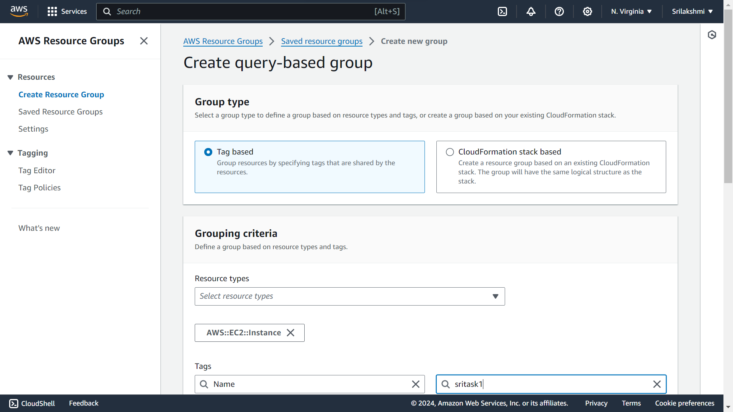

**Give tag key-Name, tag value-sritask1 and click on preview group resources**

**Configured Instance into resource group**

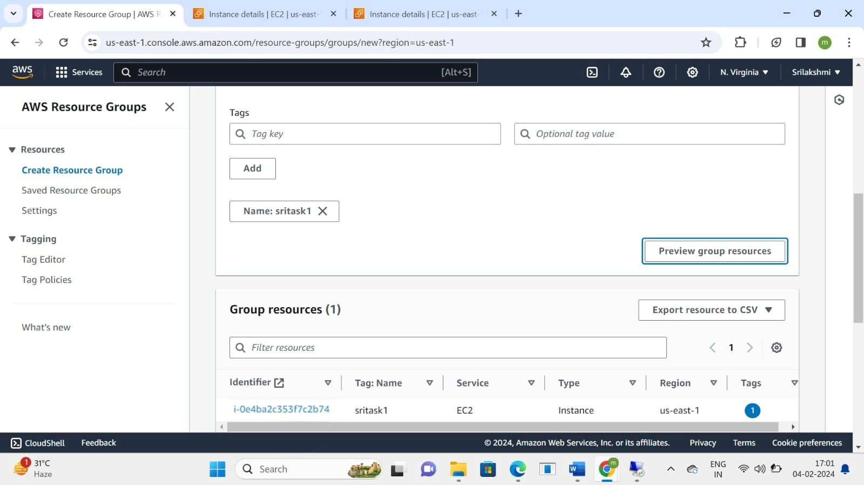

**Give group name-sriawstask1 and click on create group**

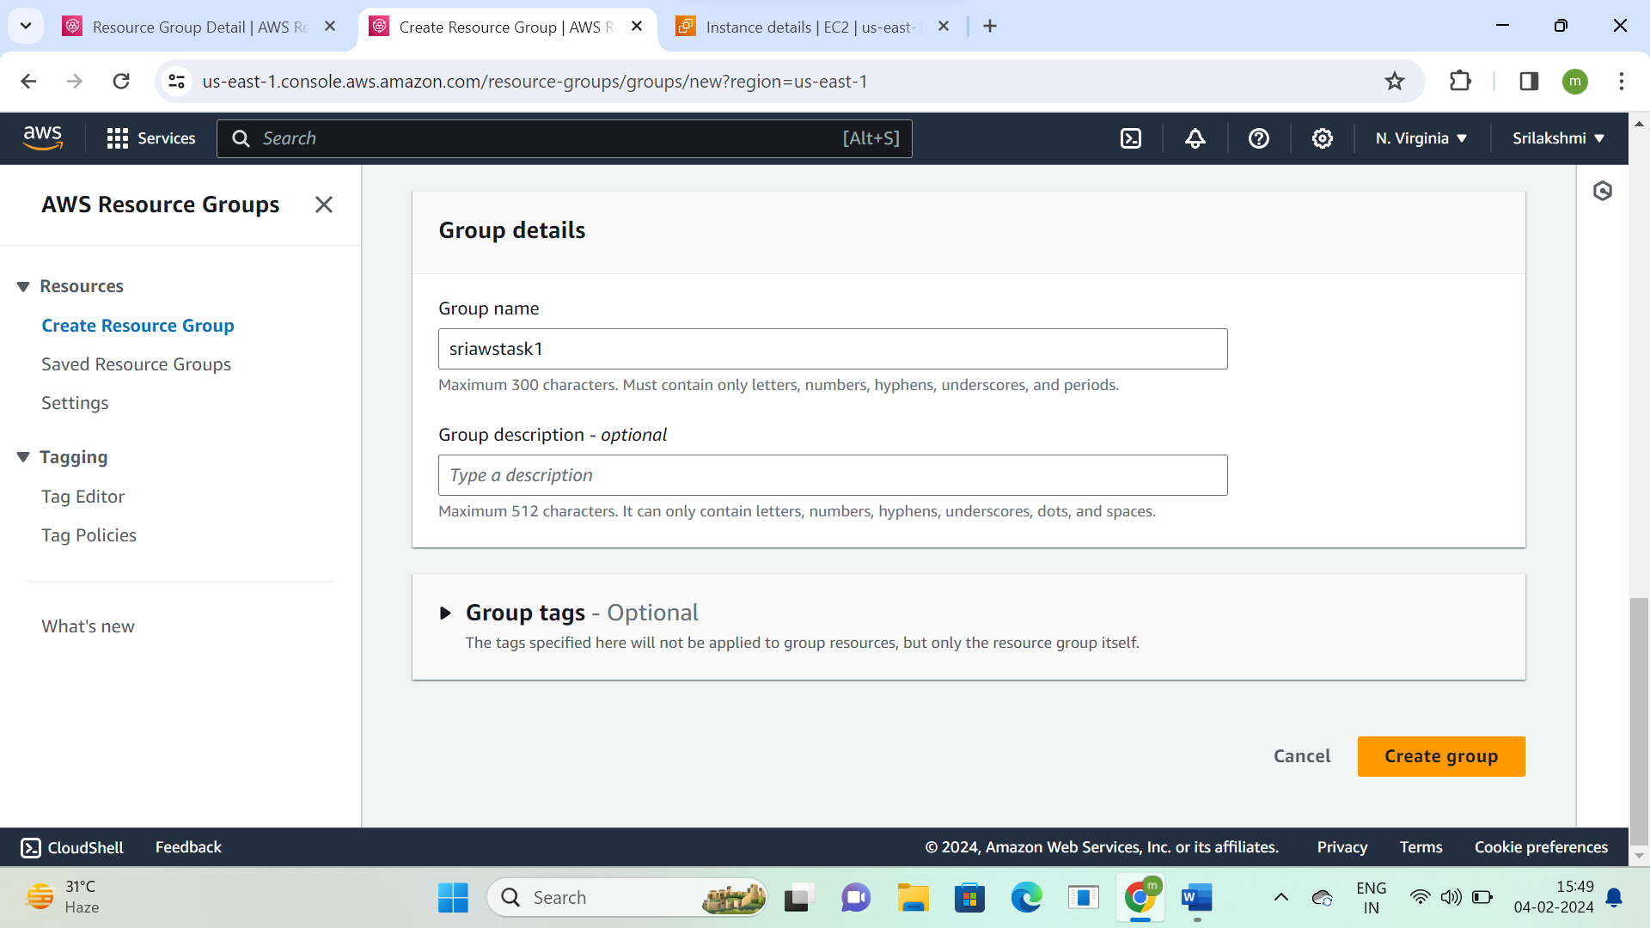

**This is the resource group details, we can edit and add instances**

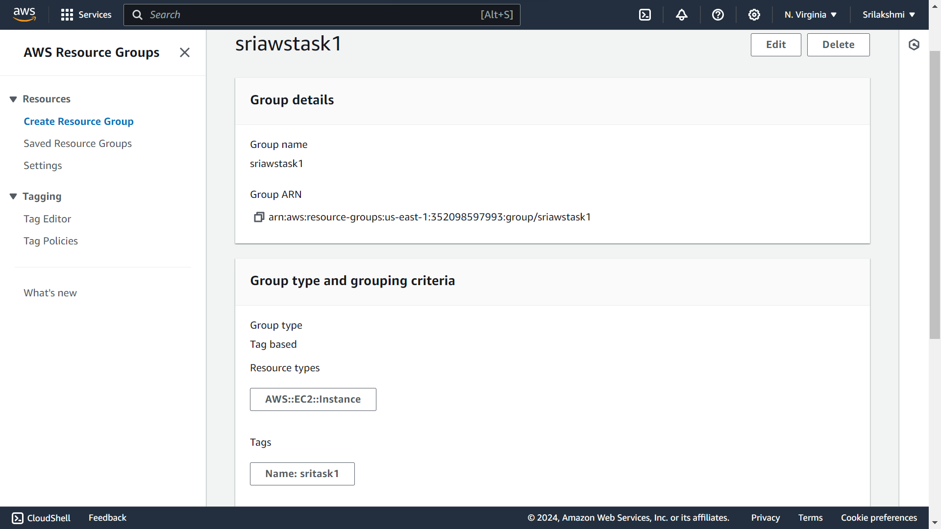

**Go to Ec2 Instance and click on connect option**



**Go to RDP client**

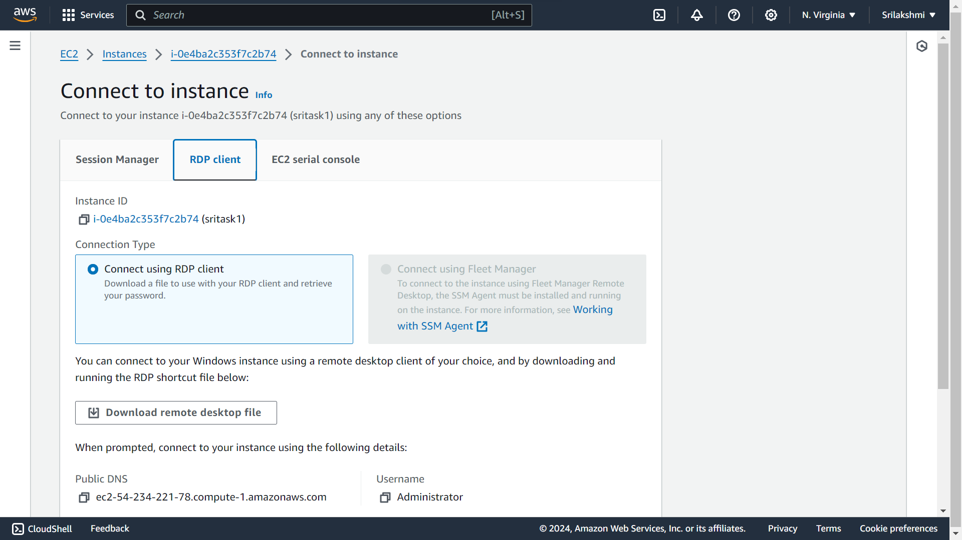

**Click on get password**

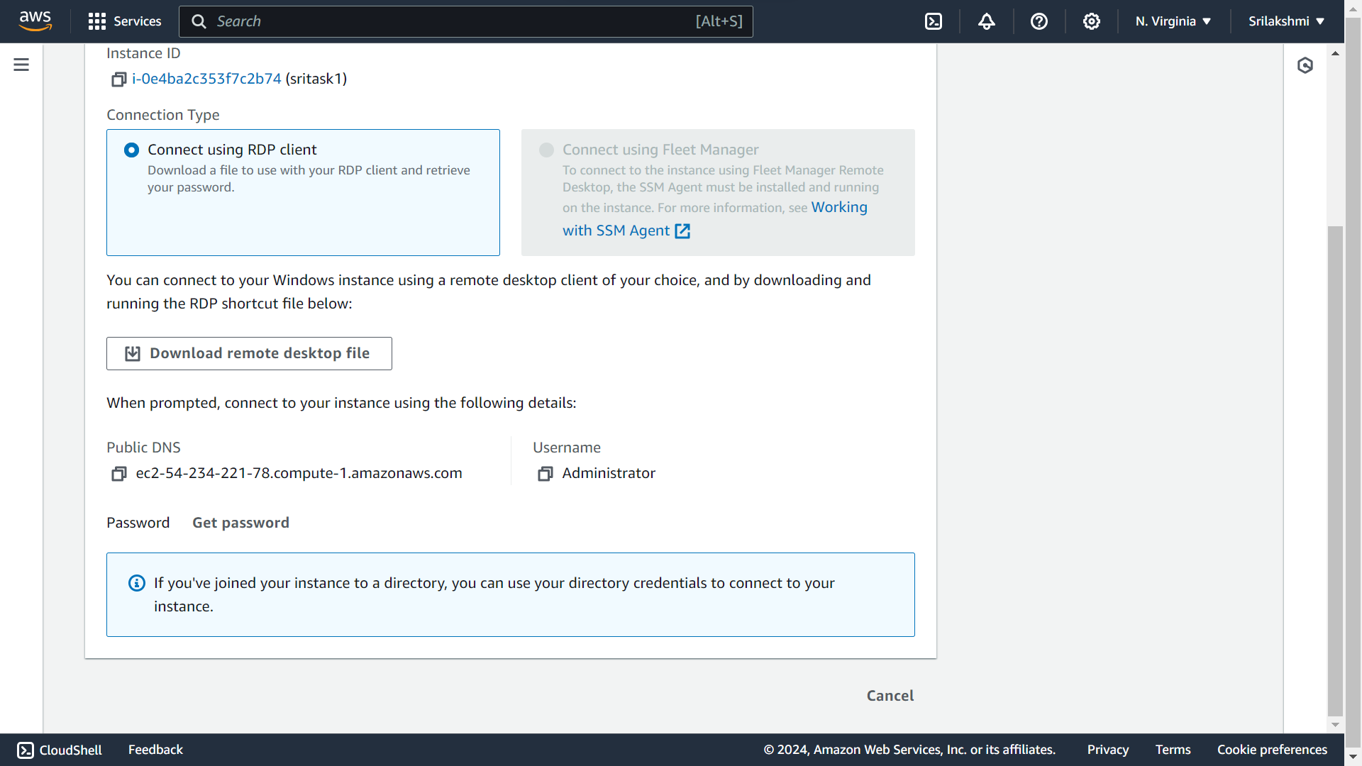

**Go to upload private key file**

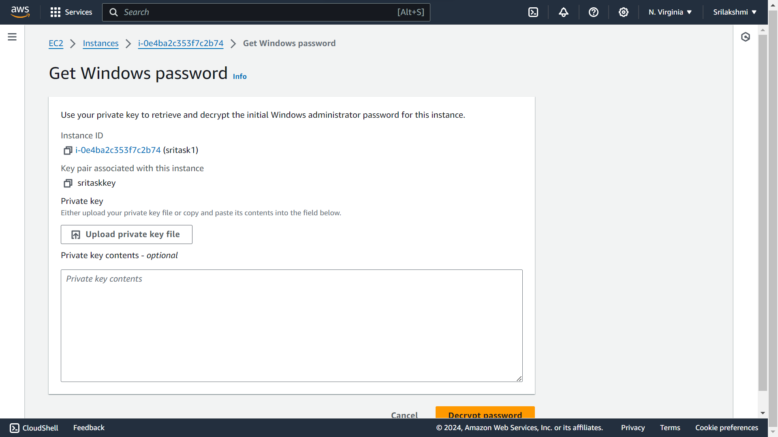

**Upload the private key file from downloads**

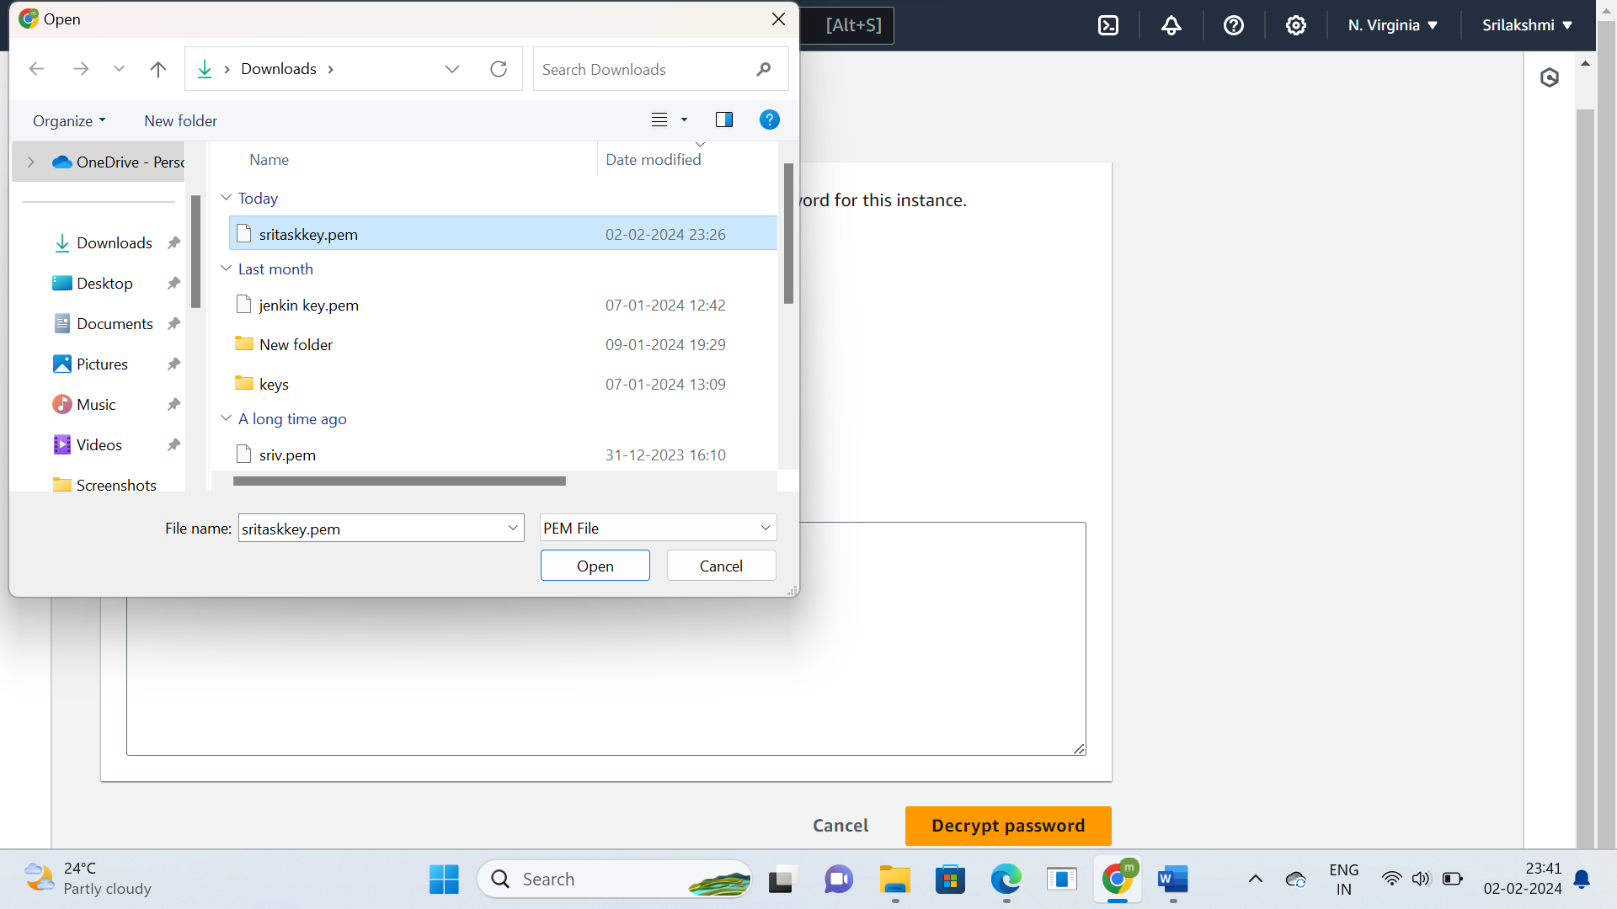

**Decrypt password**

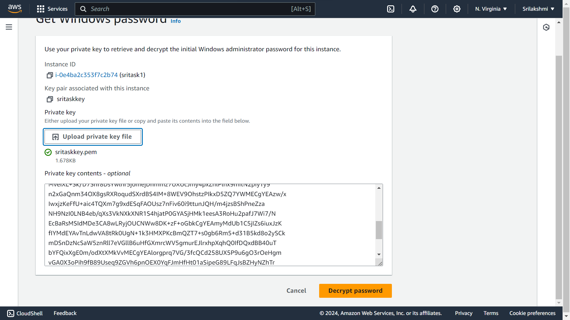

**Search windows for RDP**

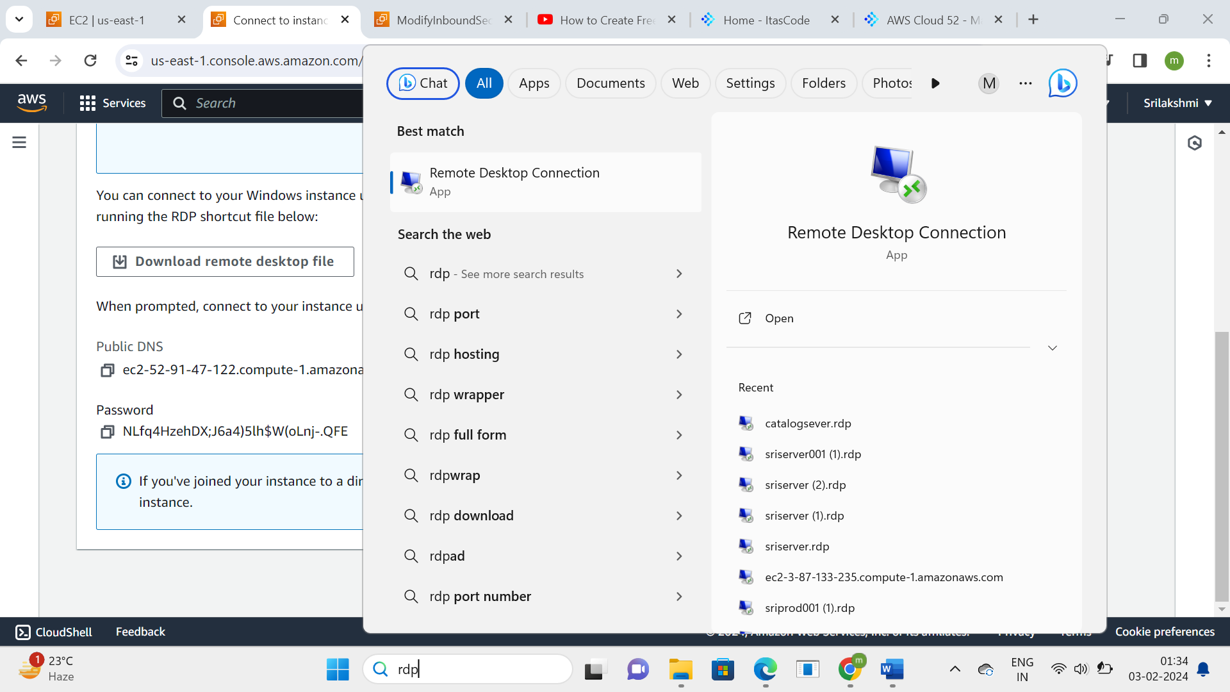

**Copy DNS ID and paste in RDP**

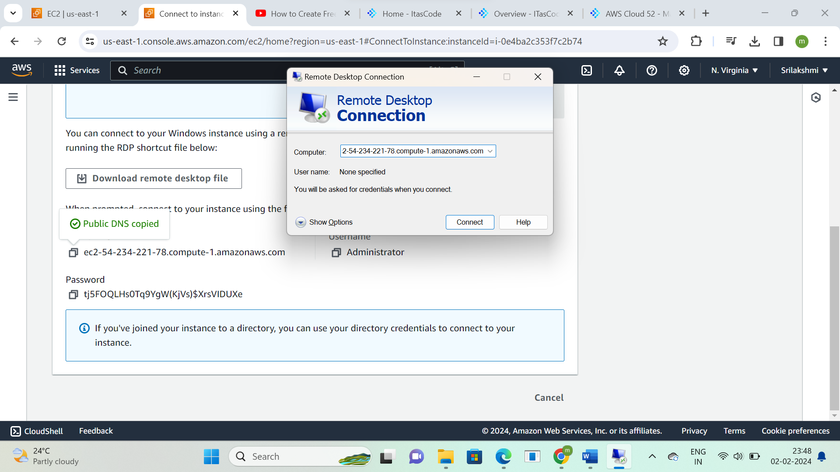

**Give credentials-User name and password**

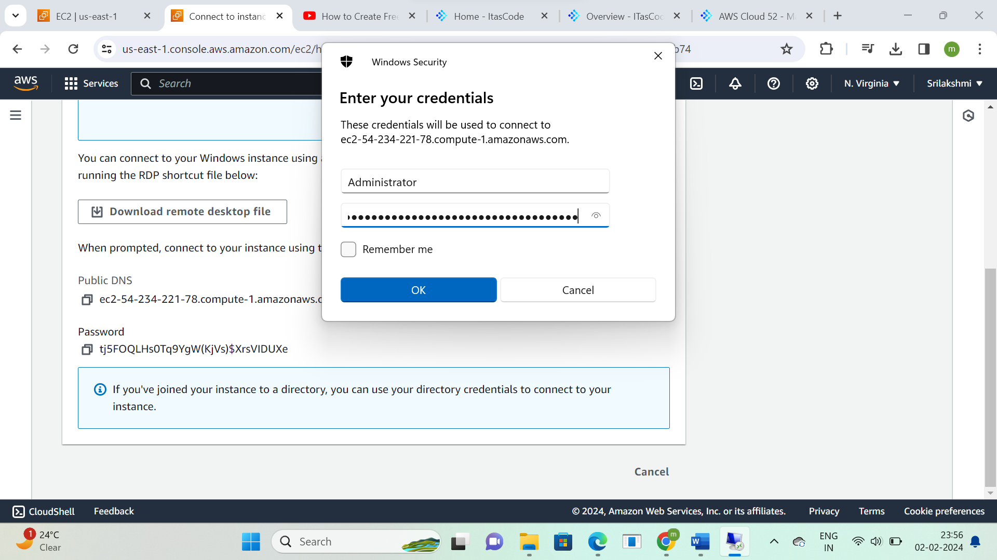

**Click on yes**

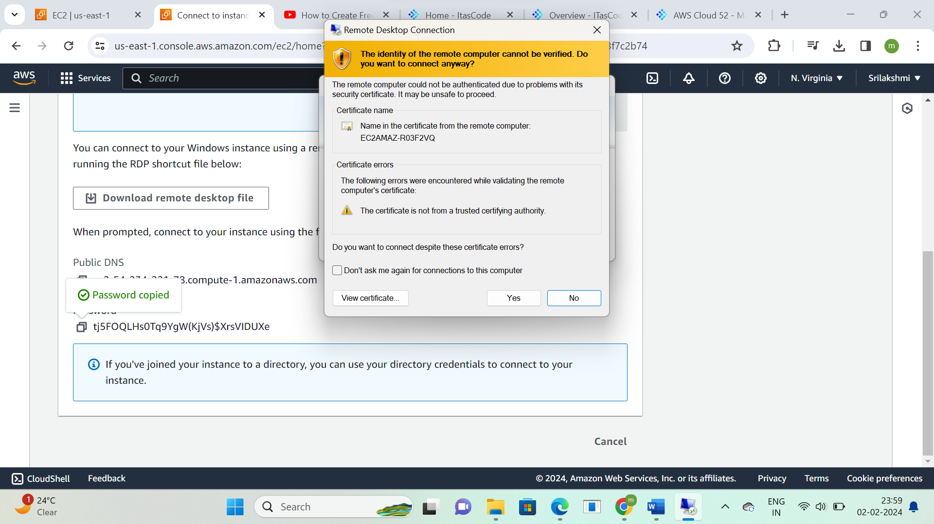

**It is Redirecting to the new Desktop**

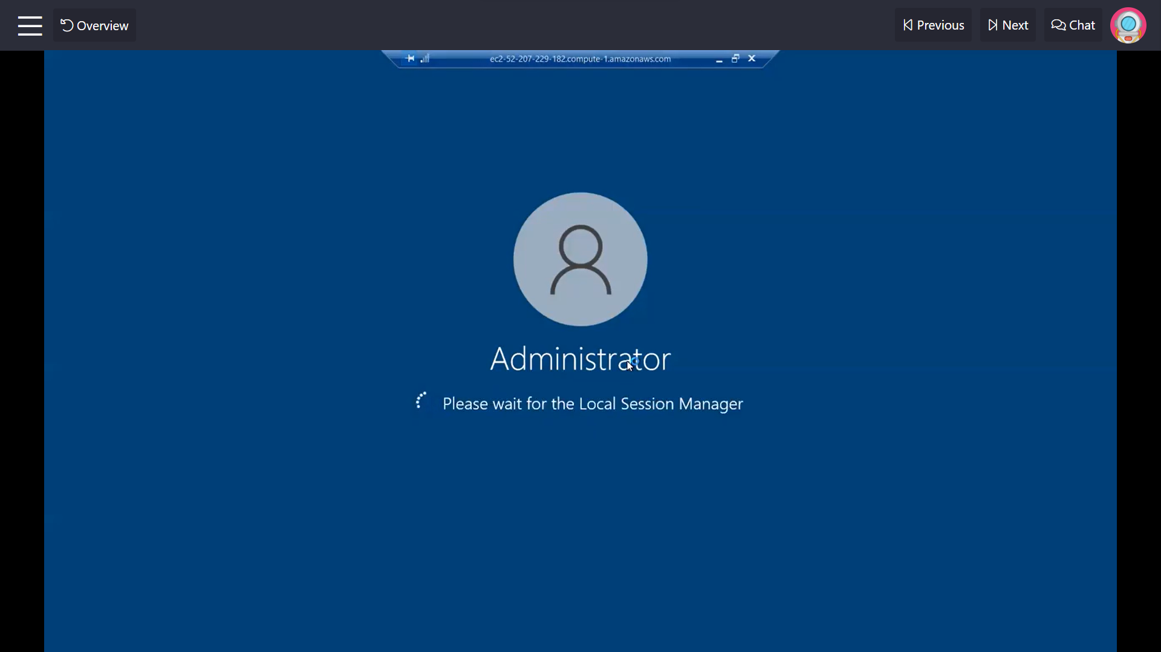

**This is the remote desktop connection created from AWS (Virtual machine)**

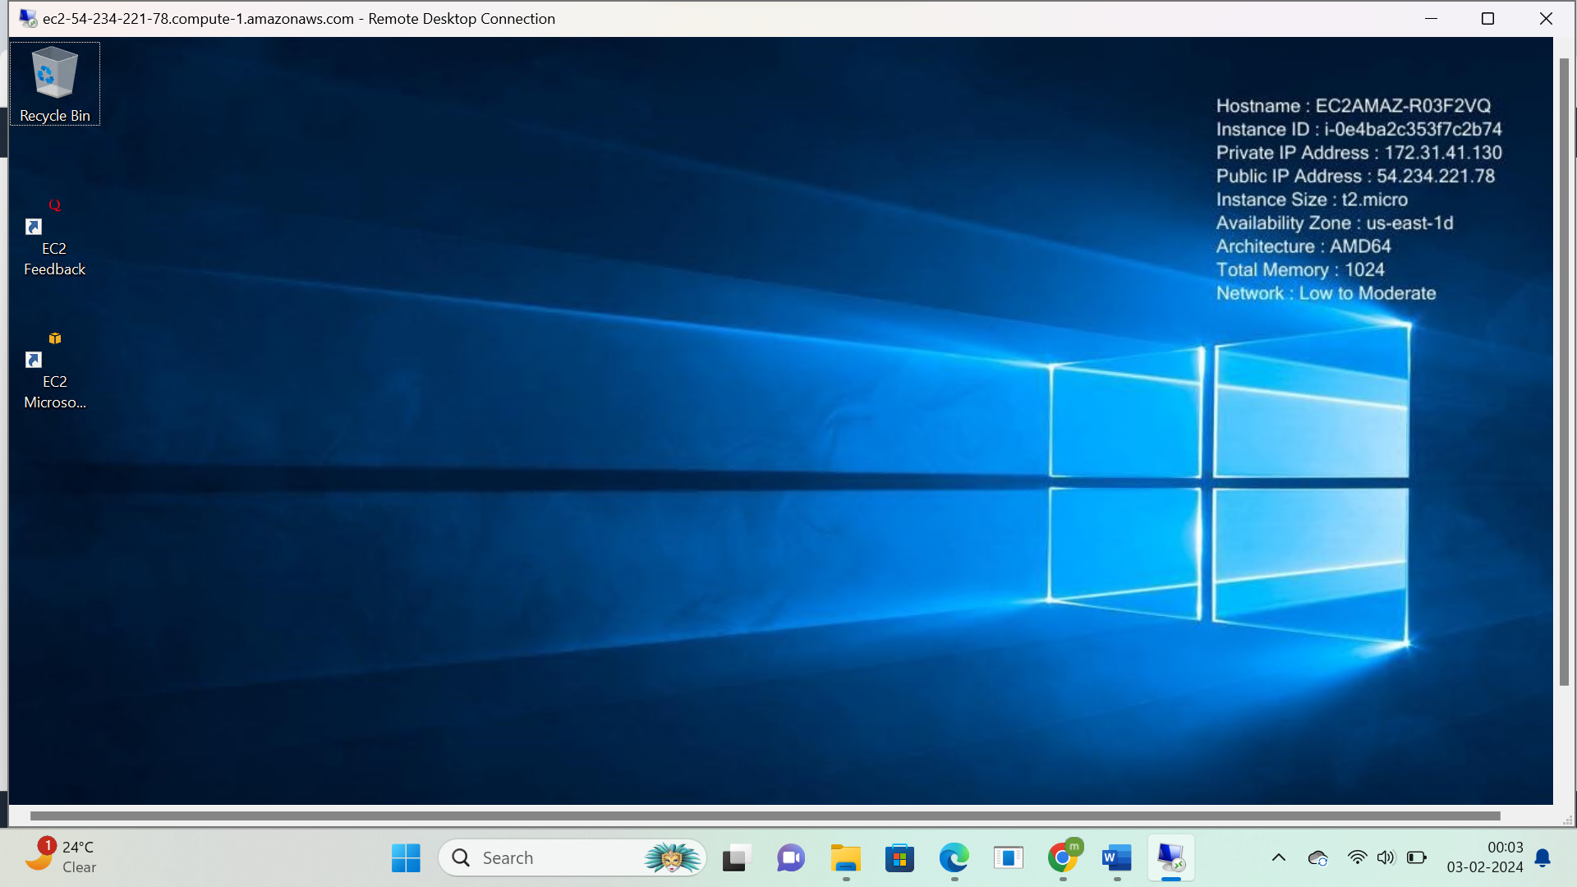

**A virtual machine is a digital copy of a physical machine.**